Label the following continents and oceans. Make sure you color code them and complete the key below

⃝ Australia ⃝ Antarctica ⃝ North America ⃝ South America ⃝Europe ⃝Asia ⃝Africa

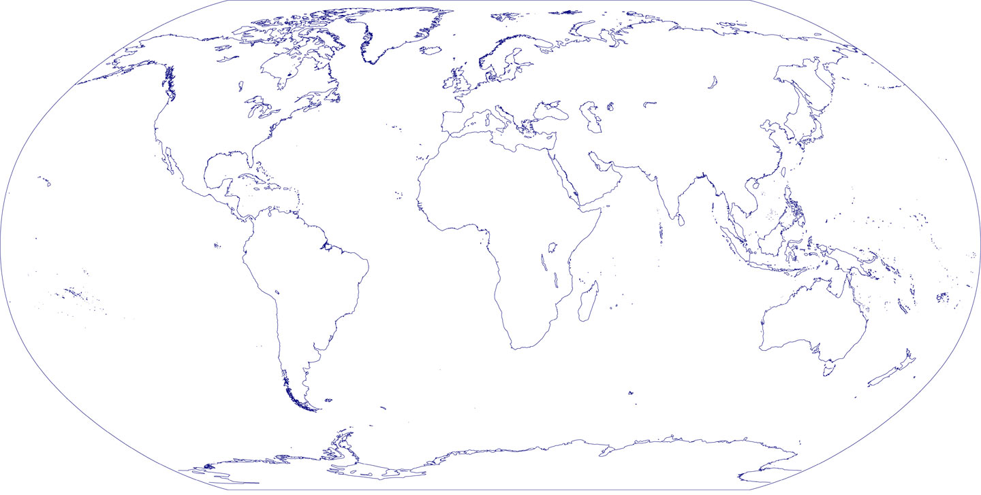⃝Pacific Ocean ⃝ Indian Ocean ⃝ Arctic Ocean ⃝Atlantic Ocean ⃝ Southern Ocean

