Ice Man Information
Use the following information to help your group determine the type of life that the ice man lived, and what he was doing when he was found.

His Discovery:

Ötzi the Iceman was found near Hauslabjoch in the Ötzal Alps on September 19, 1991, by Helmut and Erika Simon, two vacationing German hikers.
Helmut was walking a bit ahead of his wife, when he spotted something. He thought it was some trash left by a careless hiker. But when he and his wife looked closer, they realized that they were looking at the body of a person, lying face down in some melting ice.
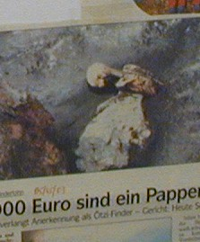
Disturbed by their discovery, they assumed that they had found the mummified remains of an unfortunate mountain climber. Since it can be difficult to recover the body of a fallen climber, especially if a fresh snowfall covers the area, many people who have died in the mountains are often left there. Their body freezes and does not deteriorate; many such mummies have been recovered.
Helmut Simon wanted to take a photo, but his wife was appalled at the thought of taking a photo of a dead person. Still, Helmut managed to take one photo of the body (he had only two left photos on his roll of film). Then he got closer in order to inspect the body, which was in a kind of gully. He saw an object or two around the body, but they meant nothing to him.
The Simons weren't sure that they would report the body. They wondered if their vacation would be interrupted by completing police reports and other official requirements when a body is discovered.
But after hike down the mountain for an hour, they stopped at a rustic lodge for something to drink. Only then did they decide to report their find to Markus Pirpamer, the caretaker of the lodge. In turn, he called the proper authorities who said they would recover the body the following day. The Simons, believing that they had discovered only a modern corpse, could not wait and continued down the mountain, heading for their hotel. Before they left, they provided Pirpamer with directions to the findspot.
When the authorities arrived, they were well aware that the glacier had been melting. Three weeks earlier, the bodies of a man and woman who had gone hiking in 1934 and never returned had been discovered. For this reason, they, like the Simons, assumed that the person had died in a climbing accident.
This explains why the Iceman's "rescuers" made quite a few careless mistakes: they weren't trying to preserve and protect the body, they were just trying to free it from the ice. At first, using a stick that they found nearby (later discovered to be his bow), they attempted to pry him free. They also tried to pull him from the ice by grabbing onto what was left of his clothing. In the process, they shredded it. One policeman was so anxious to free the mummy that he took a small jackhammer to the ice, accidentally drilling a hole in the Iceman's hip. And Pirpamer used an ice pick to finally extract the Iceman.
When he was finally freed, the Iceman was forced into a coffin, which caused his left arm to break. Then, when photographers were given time to take pictures of the mummy in a nearby morgue, a fungus began to spread across the Iceman's skin.
In the end, Italian and Austrian authorities were shocked to discover that, rather than being a modern-day mountain climber, the man had died about 3000 B.C. He quickly came to be known as the Iceman, one of the oldest and best preserved human mummies ever found.
Equipment:
- a longbow made of yew
- a chamois hide quiver
- fourteen arrows (only two finished)
- a copper ax
- a flint-bladed dagger with a woven sheath
- a tool for sharpening (retouching) flint
- a larch wood frame and cords of a backpack (pannier)
- ibex bones
- two birch-bark cylinders
- a calf leather belt pouch
- a tassel made with a white marble bead and twisted hide strips
- two pieces of birch fungus (each threaded with hide strips)
- other tools
Interesting notes about the equipment:
1. The copper ax. Scientists were thrilled to find the ax, the only complete prehistoric ax ever discovered.
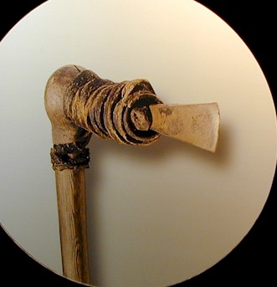
The ax is about two feet long, it was made from a portion of the trunk of a yew tree where a right-angled branch grew. The haft of the ax (i.e., the handle) came from the trunk; the shaft (the part onto which the copper blade was fitted) came from the branch--naturally joined. This allowed maximum durability. Most copper age axes are made from ash wood (Otzi's was the first one to be found made from yew). The copper blade was fitted into the shaft and wrapped with a leather binding; the binding was coated with birch tar (i.e., boiled sap from the birch tree). The shaft was forked at the end (about 3 inches long). The ax blade extended out of the leather binding about one inch.
The ax would be used quite differently from a modern one: three chops of the Iceman's ax would equal one swing from a modern one. Scientists even reconstructed his ax to make sure that it would work. It took 45 minutes, but a man was able to chop down a yew tree using the ax.
2. The dagger and sheath. The Iceman's knife was only 5 inches long. Its flint blade resembles an arrowhead; it was driven into the wooden handle. Since the handle split when the blade was attached, someone had tied the handle securely together with sinew (or animal tendon). The sheath was woven from lime bast (that is, cords made from the inner bark of a lime tree).
His Clothing:
Ötzi the Iceman was fully clothed when he died...but his clothing did not fare well during the 5,300 years that he lay undiscovered in the glacier. A good part of it disintegrated...and when he was found, he was mostly naked except for his shoes.
Still, researchers were pleased to find any clothing at all, since this type of material is very rare. When his body did appear from the ice, the back of his clothing was badly damaged (some even blew away), but because he was lying face down, substantial parts of his clothes were saved.
- two shoes
- a kind of goatskin coat
- a bear fur cap ties with two leather straps
- two goatskin leggings
- a goatskin loincloth
- a woven grass mat (for protection from the rain and cold and worn most likely over the head)
Interesting notes about his clothing:
1. His shoes. When he was discovered, the Iceman was wearing only his right shoe. They were made of various animal skins: bearskin soles, deerskin insteps, and chamois/cow/calf/linden bark uppers. The uppers were worn with fur on the outside and laced up. Dried tree bark (lime bast) was also stuffed inside the shoes to keep his feet warm. Although these are the oldest "shoes" ever found, a pair of 10,000-year-old slippers was discovered in Oregon, so they are the oldest footwear.
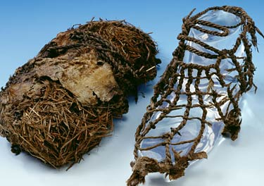
2. The grass mat. The mat, woven from swamp grass, was found in three separate pieces. At first, archaeologists believed that this was a cape, but the shoulders part of the cape seemed too narrow to be of any use. Instead, researchers now believe that this mat was worn over his head...as a type of protection from the rain (or possibly even snow) or possibly as a kind of backpack.
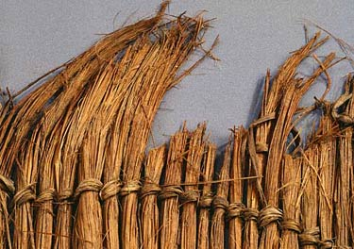

Ötzi also had tattoos. Because they were hard to find on the mummified body, the number has varied over the years. Now researchers believe that they have found them all: 61 tattoos in all.
The tattoos were made by rubbing charcoal into punctured areas in his skin. According to Discover, the tattoos "are organized into 19 different groups. Each group of tattoos is simply a set of horizontal or vertical lines."
Since many of the tattoos are found in places where he had known ailments (such as arthritis) and where acupuncture treatments are typically done to alleviate pain, Ötzi's tattoos may provide evidence for knowledge of acupuncture techniques in the Copper Age.
Location:
