Semester 1 – Common Assessment Study Guide KEY

List the Five Themes of Geography
1. Movement
2. Regions
3. HEI
4. Location
5. Place

1. Describe Latitude and Longitude. What are the two most recognized lines of each and how do they divide the Earth?

Prime Meridian is a line of longitude. It divides the Earth into the Eastern and Western Hemispheres. The Equator is a line of latitude that divides the Earth into the Northern and Southern Hemispheres.

2. Explain/define the Theme of Location and the two different types of location with some examples for each.
Absolute: Uses latitude and longitude to find a specific location.
1. Examples: 65° N, 120° E

Relative Location: A point or place in relation to another point or place.
2. Examples: Burger King is across the street from Juan’s house.

3. Explain/define the Theme of Movement

The movement of people, goods, and ideas from one location to another.

4. Explain/define the Theme of Human Environmental Interaction (HEI). Give examples of humans adapting, modifying, and depending on the environment.
The way humans and the environment interact.
A tornado destroying a bridge.
Clearing the land of trees to build a subdivision
People who live on islands eating a lot of fish.
People settling near a water source.

5. Explain/define the Theme of Region and explain what unifying characteristics are. What regions could you say we are a part of?

A common (unifying) characteristic that makes a place similar to or different from another place.

Great Lakes Region
Midwest Region
Metro Detroit

6. Explain the different types of maps and what they are used for.

Physical maps: Show landforms, elevation, and bodies of water
Political maps: Show boundaries, cities, states, countries, provinces.
Special Purpose Maps: Maps that have a specific use or purpose (election map, road map, mall map).
Always read the map’s title!

7. What are the cardinal and intermediate directions (draw a compass rose and label).
Cardinal: North East West South
Intermediate: The directions in between the cardinal directions.

8. Name the parts that every map should have and describe their purpose.
Title: what the map is about.
Key or legend: symbols and their meanings.
Scale: Shows the distance between places.
Compass rose: Directions

9. Fill in the government chart below.
Government Type | Power Held By… | Power Obtained By… | Sample Leader
Democracy | Representatives of the citizens | Voters | President Trump
Monarchy | Individual | The ruler comes from a line of previous rulers (by birth). | King Henry VIII  Queen Elizabeth
Dictatorship | Individual | Military force | Kim Jong Un

10. Economic Systems: Identify the characteristics of the following economic systems:
Socialism (mixed) – An economic system in which the government runs all primary/basic industries (needs), and the citizens control all non-basic/free enterprise (wants).

Communism (command) – Government controls production and distribution of resources, goods, and services for the benefit of the people.

Capitalism (Free Market) - People control all basic and non-basic industries.

11. Where does most of the population live in Canada? –(overall and the region)

Most Canadians live along the southern border of Canada close to the US. And near the St. Lawrence Seaway.

12. What does it mean that Canada has a bilingual government?
Canada’s government conducts business in both English and French because that have two official languages.

13. What is the largest mountain range in Canada?

The Canadian Cordillera is the largest mountain range in Canada.

14. Label the following landforms and locations:

Nunavut, Ontario, British Columbia, St. Lawrence Seaway, Canadian Shield, Saskatchewan, Alberta, Hudson Bay. 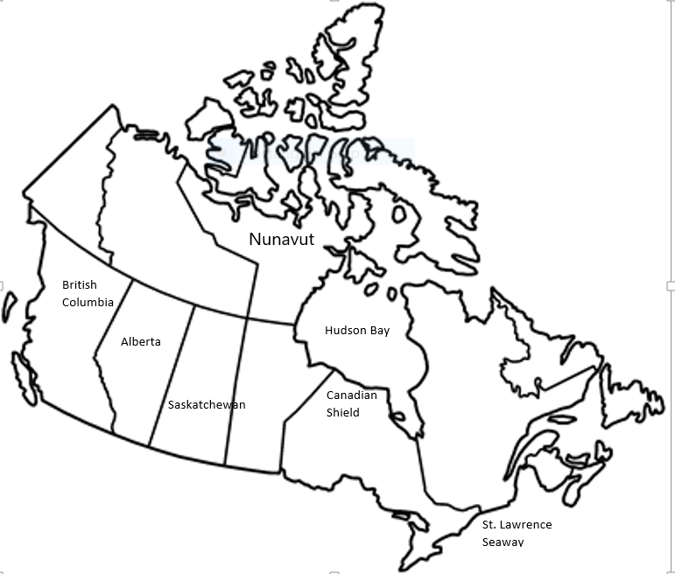

15. What are the characteristics that are common for most Latin American countries?
Most people in Latin American practice the Catholic faith, speak Spanish, and celebrate holidays such as Carnival.

16. What regions make up Latin America? Which of these is the largest?
Mexico, Central America, Caribbean, South America

17. Know the main landforms in South America.
The Andes Mountains are the largest mountain chain in South America. The Amazon Basin contains the Amazon River (which drains the most water in the world) and the Amazon Rain Forest. Southern South America contain the Pampas and Patagonia.

18. What mountain range is the largest in South America?
The Andes Mountains are the largest mountain range in South America.

19. What river drains more water than any other in the world?
The Amazon River drains more water than any river in the world.

20. Describe why and where the Panama Canal was built.
The Panama Canal was built in the Country of Panama. It was built to help cut shipping time between the Atlantic and Pacific Ocean.

21. Define rural and urban.
Rural deals with the countryside areas. Urban deals with the city areas.

22. Why are people in Latin America moving from rural areas to cities?
People are moving from rural to urban areas for a better life. The cities have more opportunities for jobs, better housing, and better schools.

23. Why is tourism an important industry in the Caribbean?
Tourism is important to the Caribbean because it has provided many jobs for the people living there. This has helped improve the economy of many Caribbean countries.

