China’s Policies Slogan T-Shirt
Name: _________________________
Hour: ________
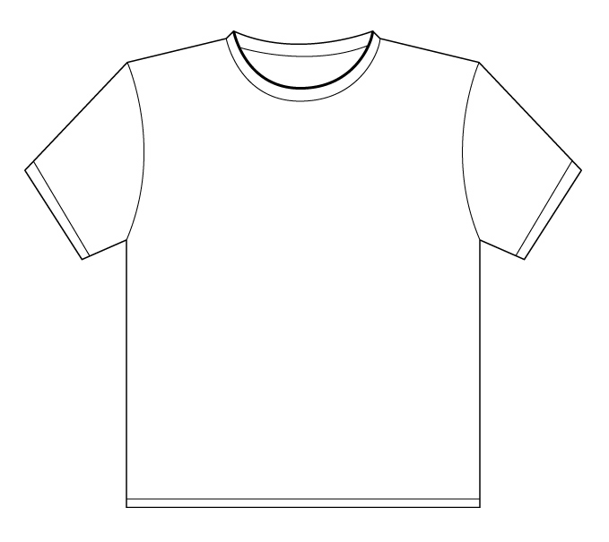
Directions: You will be creating two different slogan T-Shirts that show what your thoughts are on the policies that China implemented under their communist government and the One-Child Policy. Make sure that the t-shirts are colorful and creative and try to use humor to make your point.

